**Project 2 Proposal**

**Members:**

* Jamison Uhruh, Ivan Pinedo, Megan Zimerman, Karl Konzi

**Github Repository:**

https://github.com/i1620/Project-2.git

**Overview:**

Our goal is to create an interactive COVID dashboard to monitor the continued impact of the virus by state. We will specifically be looking at COVID death rates in states broken down by race/ethnicity and the economic impact the diversity shows.

**Questions Asked:**

* Is there a correlation between poverty levels and death rates of COVID by county?
* Is there a correlation between race/ethnicity and death rates of COVID by state?
* Is there a correlation between race/ethnicity and death rates of COVID by county?

**Visuals:**

Line graph of all US states using Plot.ly

* National data looking at cases, deaths, and hospitalizations throughout the year

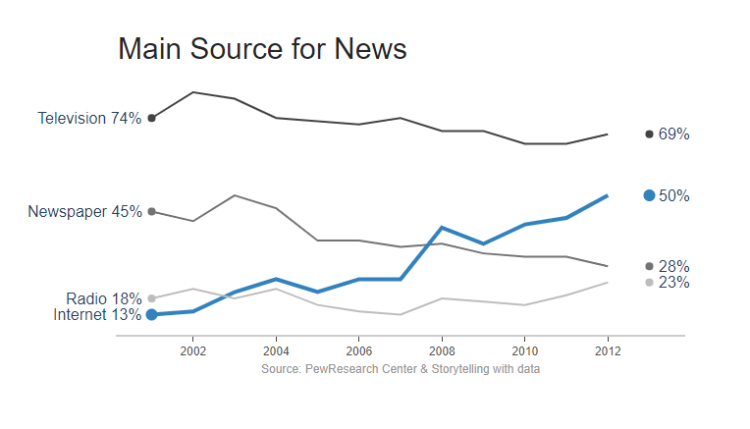

US Map using Leaflet

* Gradient color scale per number of COVID cases
  + Possibly will include county breakdown
* Interactive by specific months, current number of cases, and confirmed cases by race/ethnicity

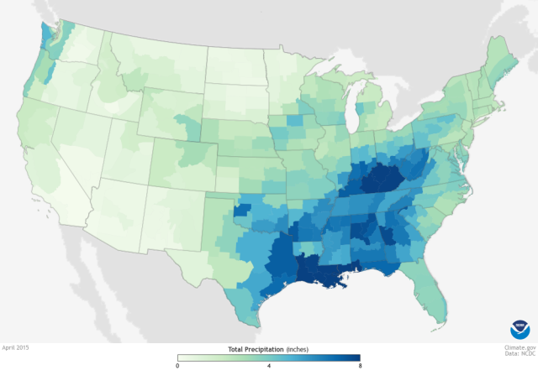

COVID by Race using D3

* State by state infection line charts broken down by race/ethnicity
* X-axis to toggle between cases and deaths (hospitalization data not available by race)
* Look at counties with higher population in poverty versus death rates/positive cases compared to those with lower poverty rates

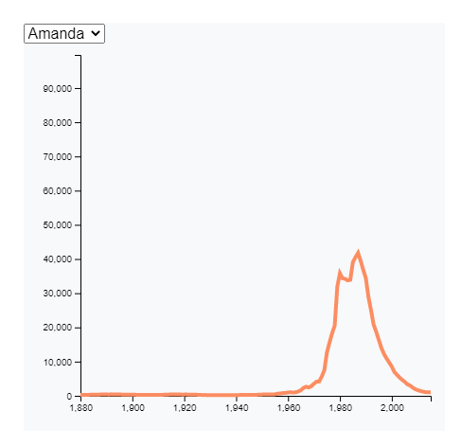

**Data sets to be used:**

Data files:

* Race Data Entry – CRDT.csv
* Race_Data_COVID.csv
* Covid_deaths_usafacts.csv
* Economics_county.xls
* National-history.csv

<https://covidtracking.com/data/api>

<https://usafacts.org/visualizations/coronavirus-covid-19-spread-map/>

<https://covidtracking.com/race>